# **FACE EMOTION RECOGNITION SYSTEM USING STREAMLIT & DEEPFACE**

## **ABSTRACT**

Face Emotion Recognition is an important application of Artificial Intelligence and Computer Vision that focuses on identifying human emotions from facial expressions. Emotions such as happiness, sadness, anger, fear, surprise, and neutrality play a vital role in human–computer interaction. This project implements a **Face Emotion Recognition System** using **Python, Streamlit, OpenCV, and DeepFace**. The system supports both **image upload** and **webcam-based image capture**, detects one or more faces, predicts the dominant emotion for each detected face, and stores the results in an Excel-compatible CSV file for further analysis.

## **1: INTRODUCTION**

Emotion recognition from facial expressions is a rapidly growing research area in computer vision and artificial intelligence. Facial expressions provide essential non-verbal cues that help in understanding human behavior and emotions. Automated face emotion recognition systems are widely used in surveillance systems, mental health analysis, human–computer interaction, customer feedback analysis, and smart monitoring systems.

This project titled **“Face Emotion Recognition System”** demonstrates a practical implementation of emotion recognition using pre-trained deep learning models provided by the DeepFace library along with a simple and interactive web interface developed using Streamlit.

## **2: OBJECTIVES OF THE PROJECT**

The main objectives of this project are:

* To detect human faces from images and webcam captures.
* To recognize and classify facial emotions.
* To support both image upload and webcam-based input.
* To visualize emotion confidence scores.
* To store emotion recognition results in an Excel-compatible file.

## **3: SCOPE OF THE PROJECT**

The scope of this project includes:

* Emotion recognition from static images.
* Emotion recognition from webcam-captured images.
* Detection of multiple faces in a single frame.
* Storage of results for further analysis using Excel.

## **4: SOFTWARE AND HARDWARE REQUIREMENTS**

### 4.1 Software Requirements

* Operating System: Windows 10 / Windows 11
* Programming Language: Python 3.x
* IDE: Visual Studio Code
* Libraries and Frameworks:
  + Streamlit
  + OpenCV
  + DeepFace
  + NumPy
  + Pandas

### 4.2 Hardware Requirements

* Laptop/Desktop Computer
* Minimum 4 GB RAM
* Webcam (for webcam capture mode)

## **5: TECHNOLOGIES USED**

### 5.1 Streamlit

Streamlit is used to develop a web-based graphical user interface that allows users to interact with the application easily.

### 5.2 OpenCV

OpenCV is used for image processing and face detection using Haar Cascade classifiers.

### 5.3 DeepFace

DeepFace is a deep learning-based facial analysis library that provides pre-trained models for emotion recognition.

## **6: SYSTEM ARCHITECTURE**

The system architecture consists of the following components:

1. Streamlit User Interface
2. Input Selection Module (Image Upload / Webcam)
3. Face Detection Module (Haar Cascade)
4. Emotion Recognition Module (DeepFace)
5. Result Visualization Module
6. Result Storage Module (CSV / Excel)

**System Flow:**

User → Select Input Mode → Image/Webcam Input → Face Detection → Emotion Recognition → Display Output → Save Results

## **7: MODULE DESCRIPTION**

### 7.1 Input Selection Module

Allows the user to choose between image upload and webcam capture modes using radio buttons.

### 7.2 Face Detection Module

Detects one or more faces from the input using OpenCV Haar Cascade classifier.

### 7.3 Emotion Recognition Module

Uses DeepFace to analyze detected faces and predict the dominant emotion along with confidence scores.

### 7.4 Result Visualization Module

Displays detected faces with bounding boxes and emotion labels. Emotion confidence scores are shown using tables and bar charts.

### 7.5 Result Storage Module

Stores emotion recognition results in a CSV file (results.csv), which can be opened using Microsoft Excel.

## **8: IMPLEMENTATION**

This chapter describes the actual working of the system.

### 8.1 Project Folder Structure

### 

### 8.2 Streamlit User Interface

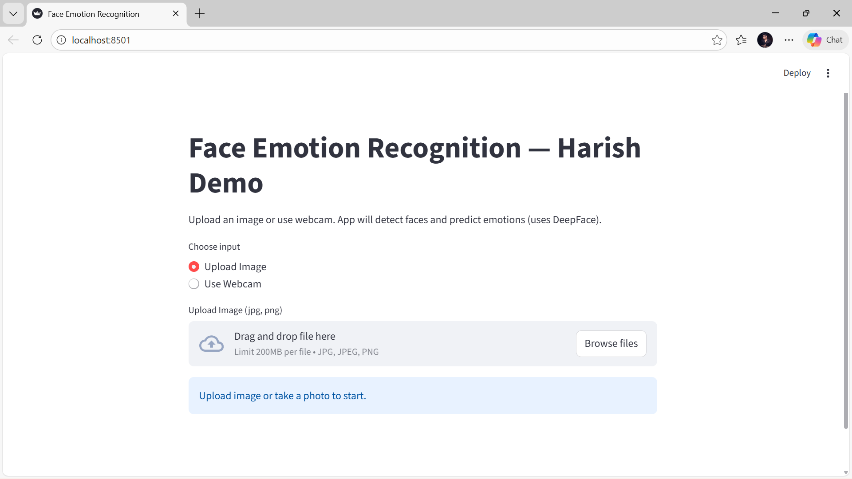

### 

### 8.3 Image Upload Based Emotion Recognition

### 

### 

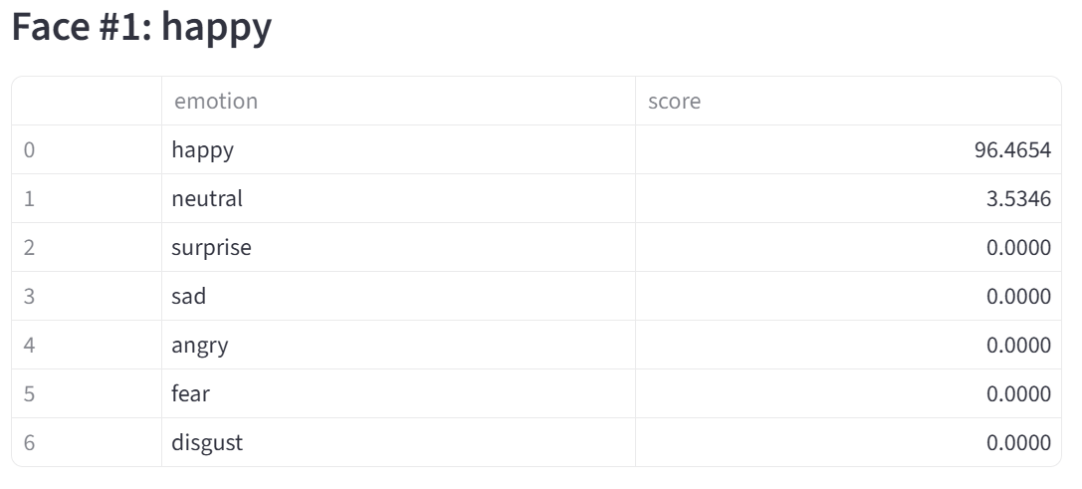

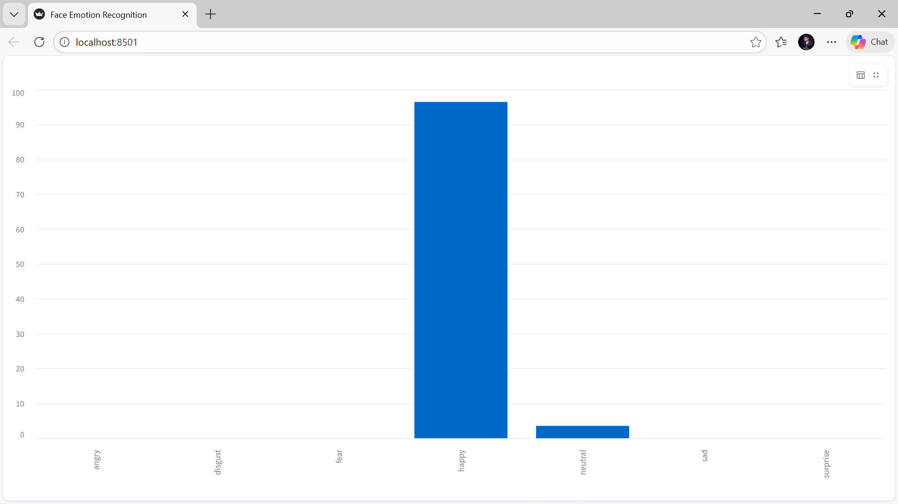

8.4 Webcam Based Emotion Recognition

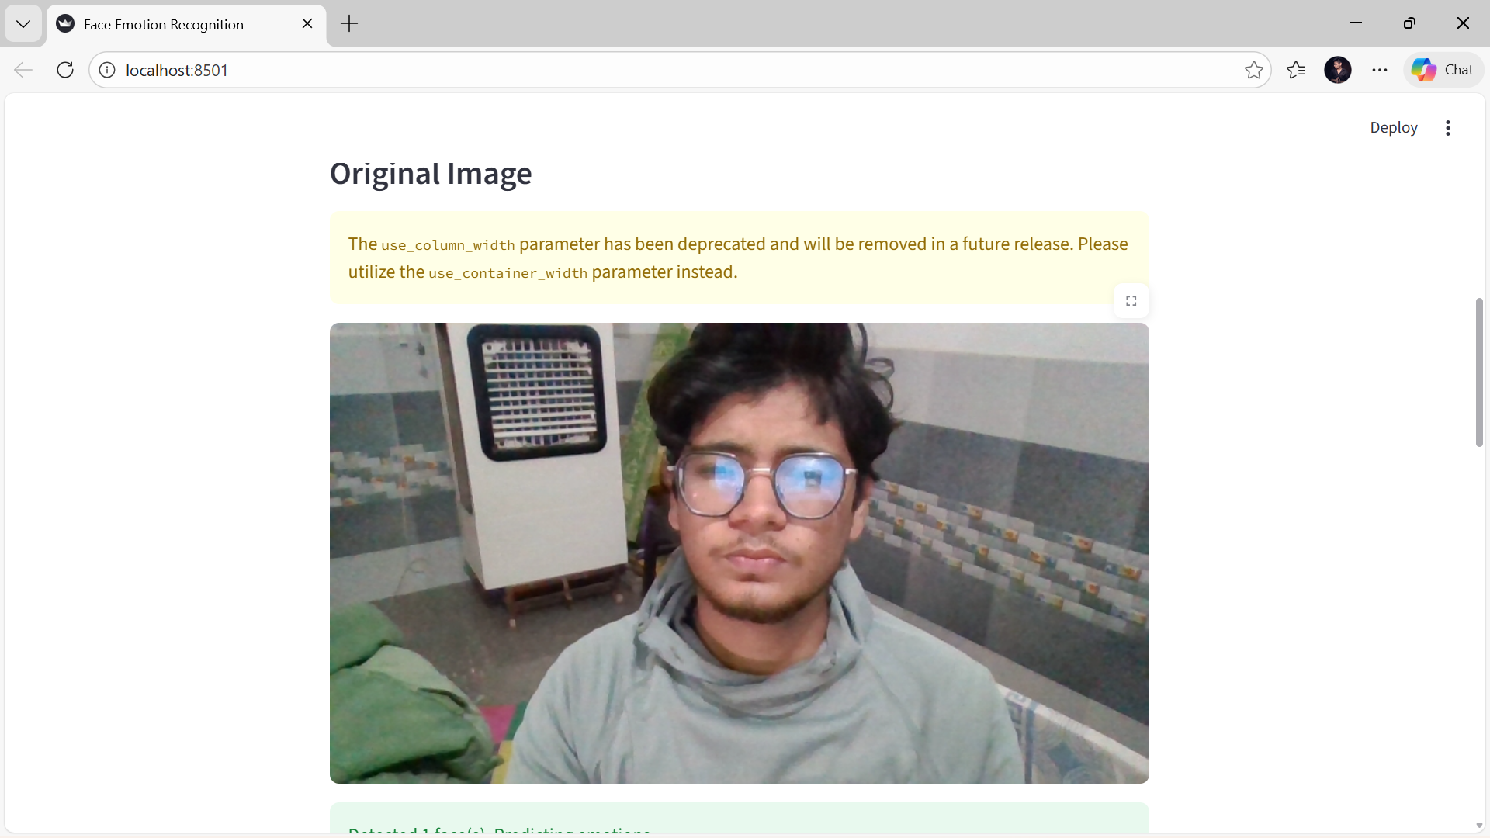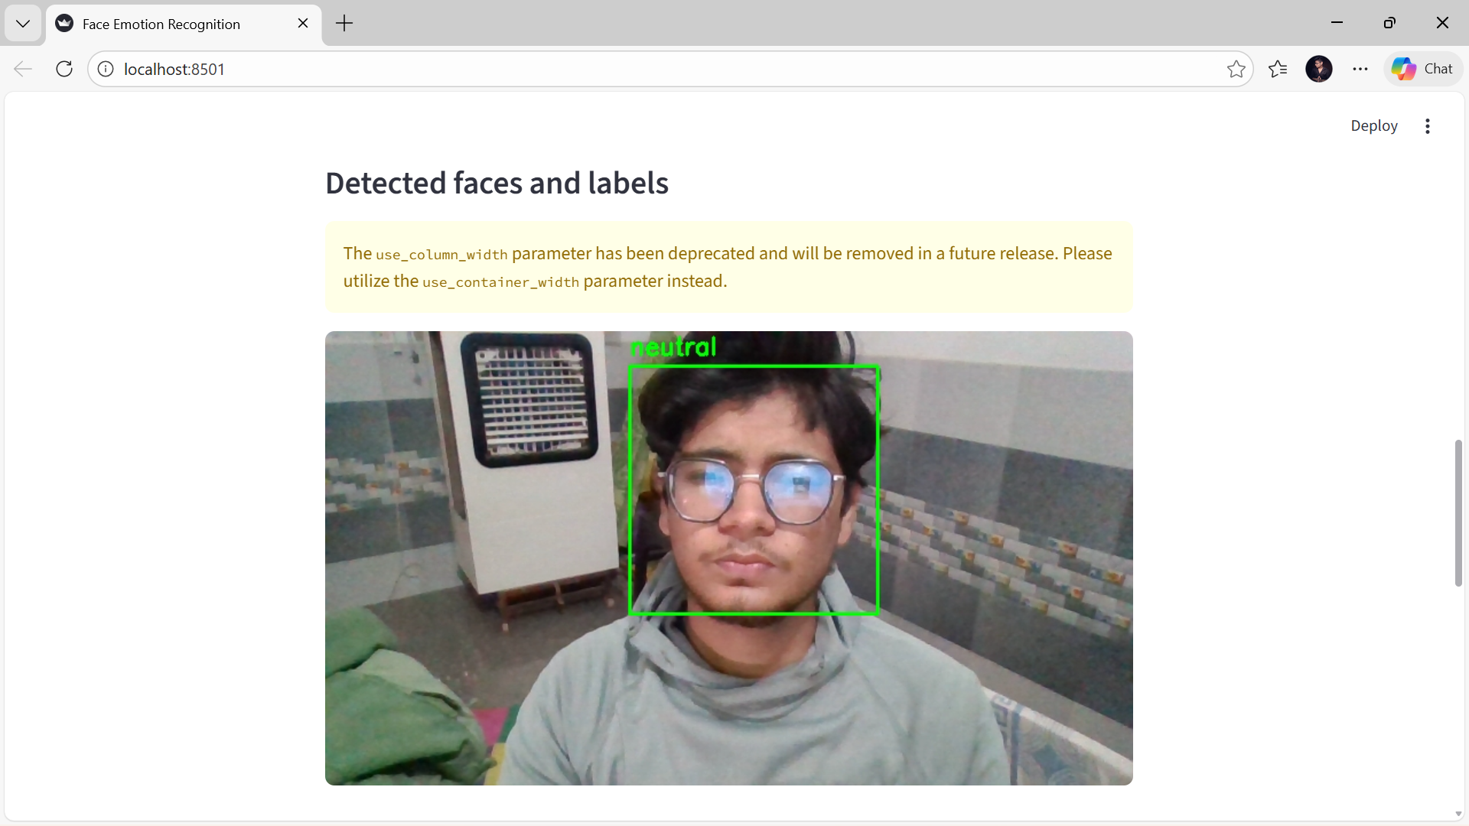

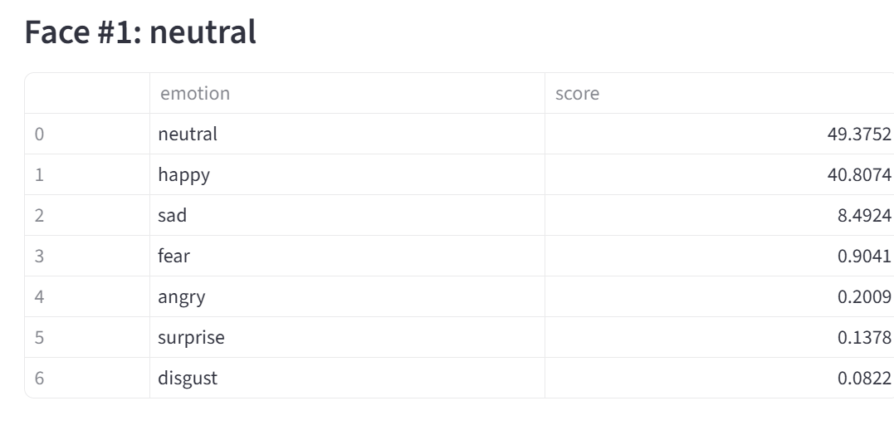

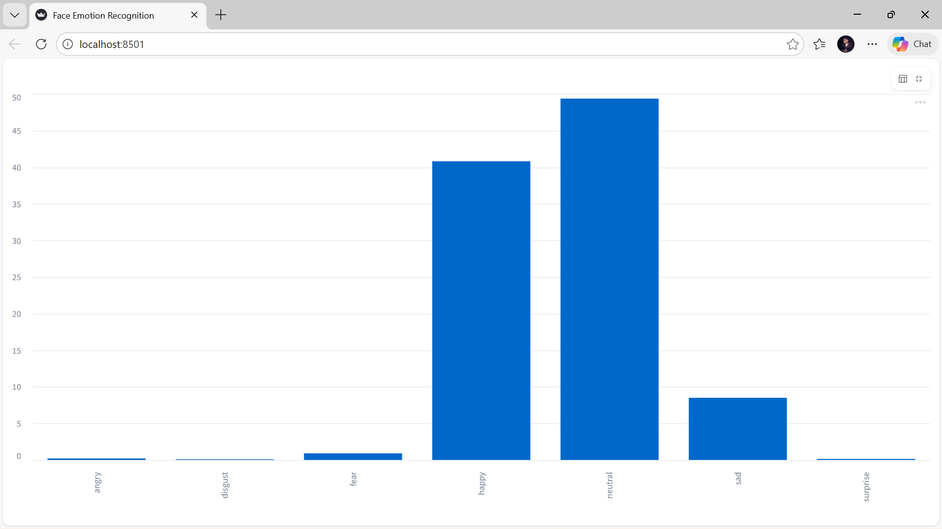

## **9: RESULTS AND DISCUSSION**

The system was tested using multiple images and webcam captures. Faces were accurately detected, and emotions were correctly predicted under proper lighting conditions. The system supports multiple face detection and provides confidence-based emotion visualization.

All detected emotions are automatically stored in a CSV file named **results.csv**, which can be opened in Microsoft Excel for further analysis.

## **10: ADVANTAGES AND LIMITATIONS**

### Advantages

* User-friendly web interface
* Supports multiple input modes
* Uses pre-trained deep learning models
* Automatic result storage

### Limitations

* Performance depends on image quality
* Accuracy may reduce in poor lighting conditions

## **11: CONCLUSION**

The Face Emotion Recognition System successfully demonstrates the application of computer vision and deep learning techniques for emotion analysis. The project fulfills its objectives by providing accurate emotion detection along with a user-friendly interface and data storage capability.

## **12: FUTURE SCOPE**

* Real-time video-based emotion recognition
* Integration with databases
* Emotion analytics dashboards
* Mobile and cloud deployment

## **13: REFERENCES**

1. OpenCV Documentation
2. DeepFace Documentation
3. Streamlit Documentation
4. Research papers on Facial Emotion Recognition

## 

## **SOURCE CODE**

### **File: app.py**

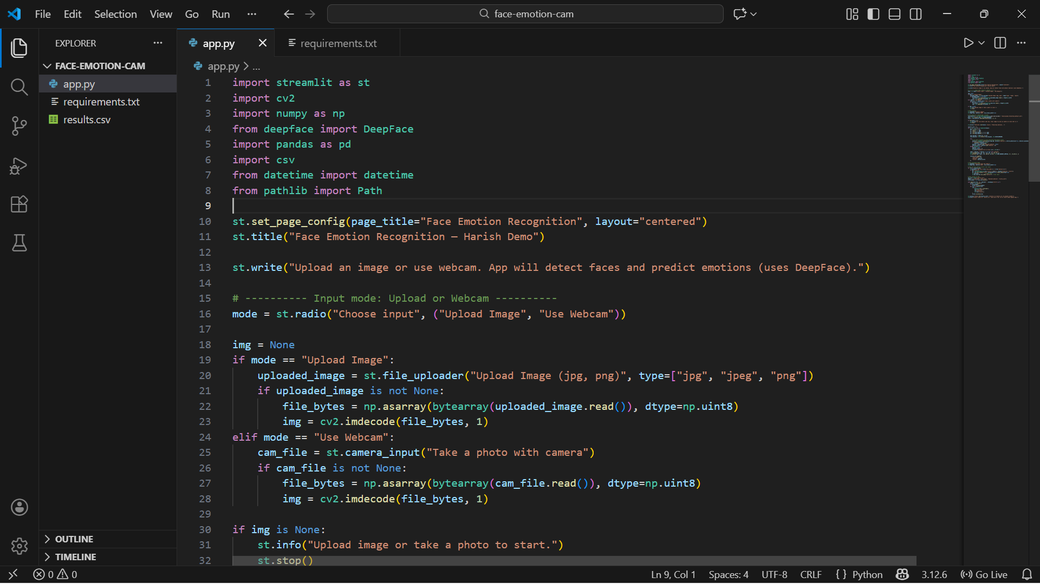

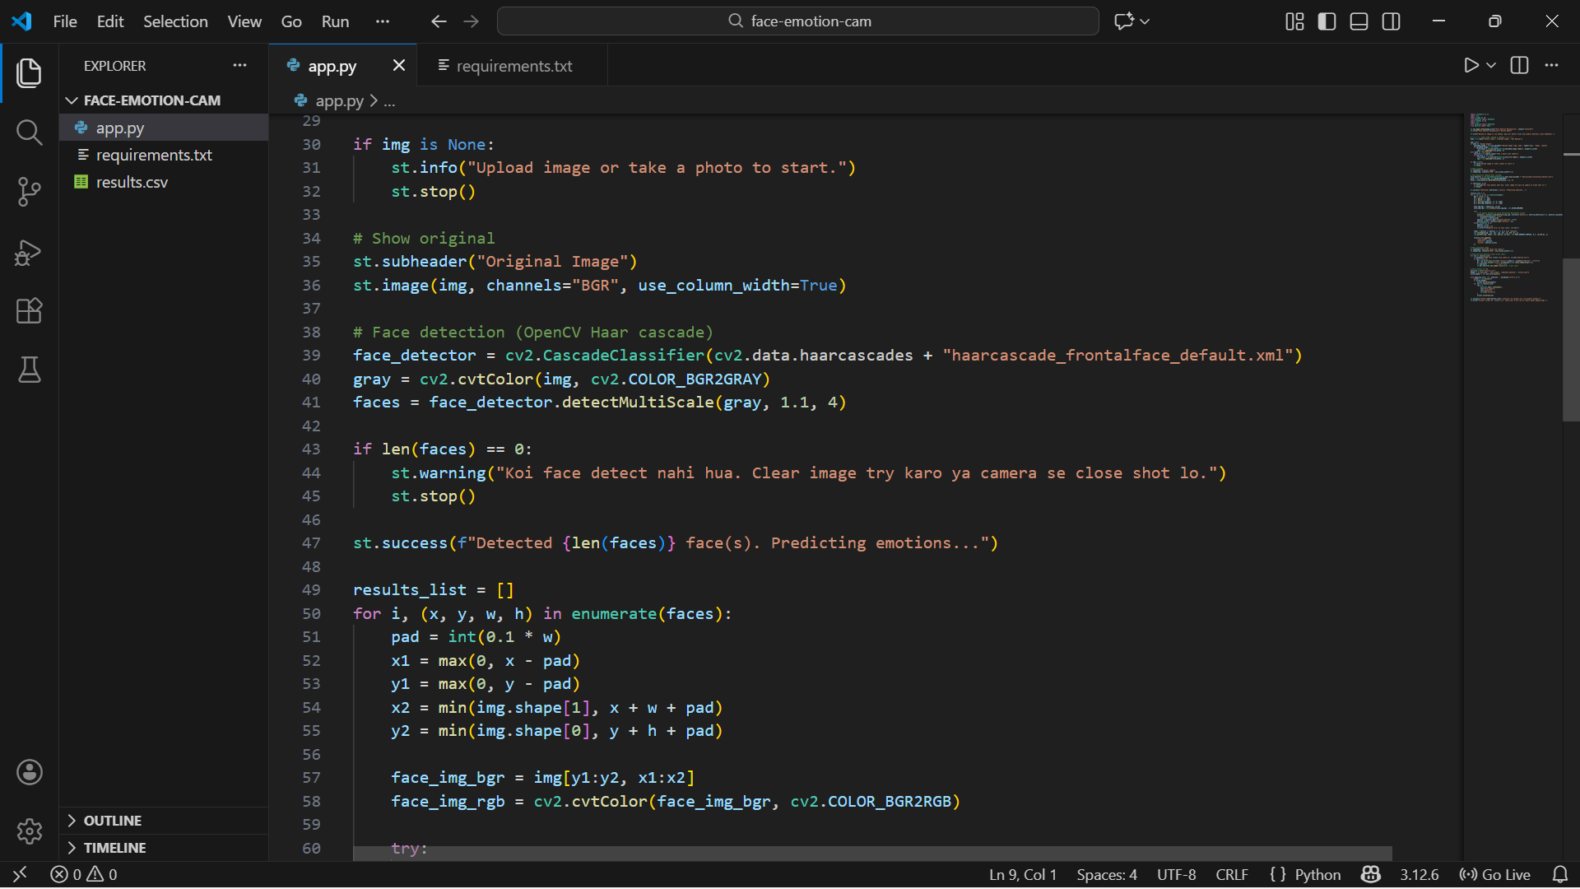

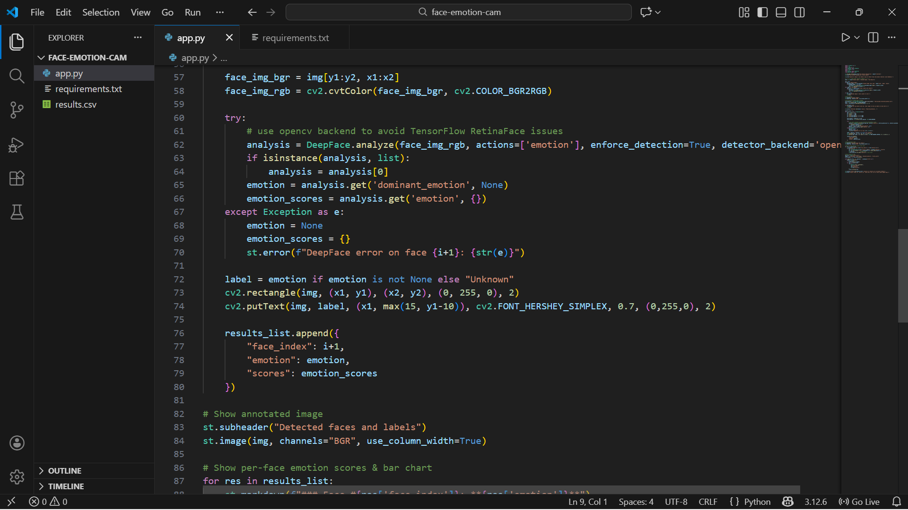

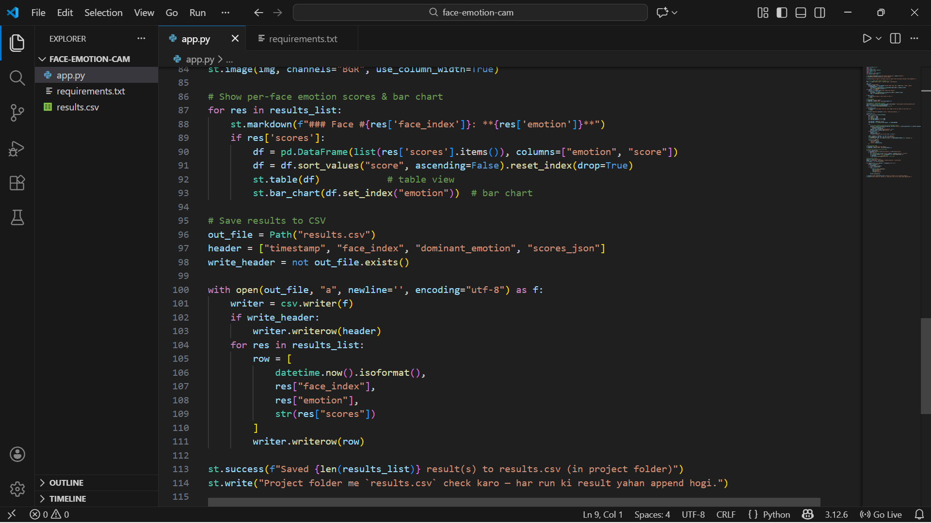

### 

### **File: requirements.txt**

streamlit

deepface

opencv-python

numpy

pandas

### **File: results.csv**

This file stores emotion recognition results in CSV format and can be opened using Microsoft Excel.

